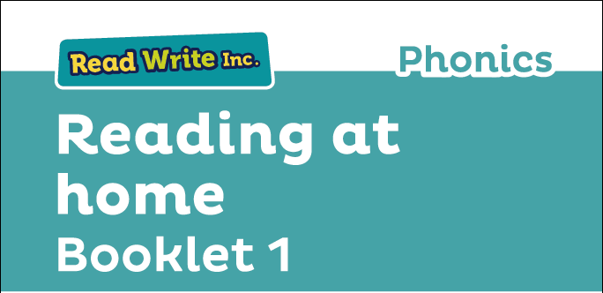

Glossary
Fred Talk – sounding out the word before reading (blending)

sound-blending – putting sounds together to make a word,
e.g. c–a–t cat

special friends – sounds written with more than one letter,
  - sh, ng, qu, ch

Speed Sounds – the individual sounds that make up words

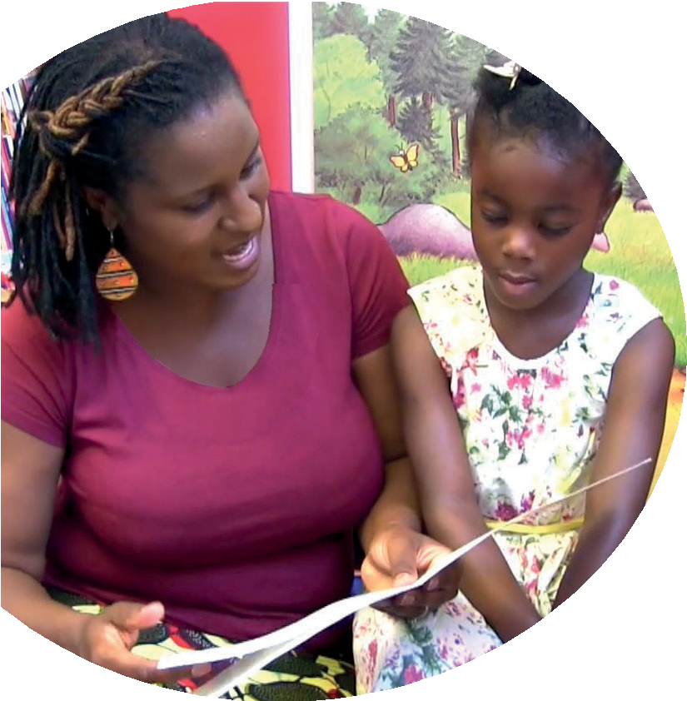
Read stories to your child with feeling! The more you love the story, the more your child will love reading.

Booklet 1 tells you how to help your child:
- read Set 1 Speed Sounds
- blend sounds into words
- read the Blending Books
- read Red, Green and Purple Storybooks.

Your child is learning to read with Read Write Inc. Phonics, a very popular and successful literacy programme. This ﬁrst booklet shows you how you can get your child off to a quick start.
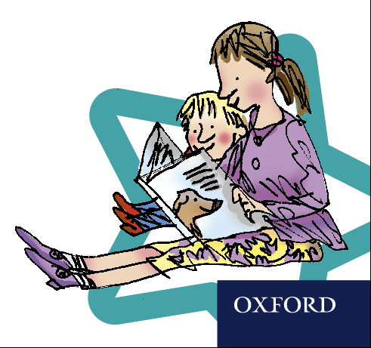
Your child will learn to read in a very simple way. He or she will learn to:
- Read letters by their ‘sounds’

Blend these sounds into words
- Read the words in a story.

www.ruthmiskin.com/parents has many videos to help you help your child.
For more information on Read Write Inc., please talk to the Read Write Inc. manager in your child’s school or visit www.readwriteinc.com.

8

1

How to listen to your child read
How will my child learn to read?

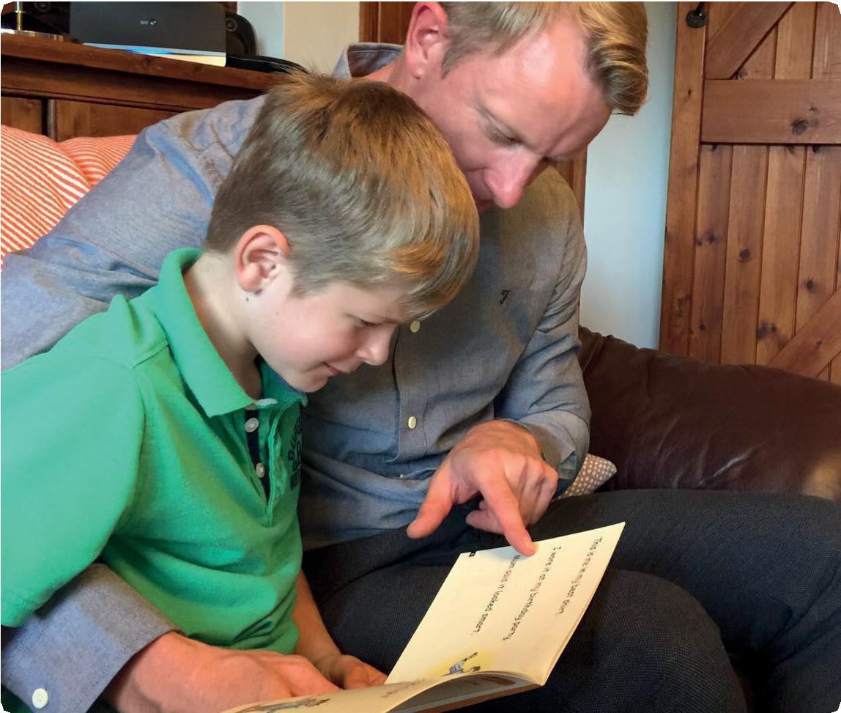
First, your child will learn to read:
- Set 1 Speed Sounds: these are sounds written with one letter:
m a s d t i n p g o c k u b f e l h r j v
y w z x and sounds written with two letters • (your child will call these ‘special friends’): sh th ch
qu ng nk ck
- Words containing these sounds, by sound-blending,
e.g. m–a–t mat, c–a–t cat, g–o–t got, f–i–sh ﬁsh,
s–p–o–t spot, b–e–s–t best, s–p–l–a–sh splash
- Blending Books and Red, Green and Purple Storybooks.

- Do not read the book aloud before your child reads it to you.
- Ask your child to read the sounds and words before he or she reads the story.
- When your child reads the story, ask him or her to sound out
- the words that he or she can’t read automatically. Don’t allow your child to struggle too much. Praise your child when he or
she succeeds.
- Read back each sentence or page to keep the plot moving. (Your child’s energy is going into reading the words not the story.)
- Do not ask your child to guess the word by using the pictures.
- Do it all with patience and love!
Second, he or she will learn to read:
- Set 2 Speed Sounds: ay ee igh ow oo oo ar or air ir ou oy
- Words containing these sounds
- Pink, Orange and Yellow Storybooks.

Third, he or she will learn to read:
- Set 3 Speed Sounds: ea oi a-e i-e o-e u-e aw are ur er ow ai oa ew ire ear ure
- Words containing these sounds
- Blue and Grey Storybooks.

We have a story time every day at school so children develop a love of stories. We hope that you will do the same by reading a bedtime story to your child every night. We have wonderful books in school for you to borrow.
Your child will be taught to say the sound for the letter and not the letter name, so ‘m’ as in ‘mat’, not ‘em’;
‘s’ as in ‘sun’ not ‘es’.

